How to convert the image?

We bring the image to be drawn in (png, .jpg, .tga, .gif, .PNG, .JPG, .TGA) format, it must be of high accuracy and contain sufficient black-and-white coordination.

# Using the StippleGen 2 program, we insert the image into the program screen as shown in the picture.

# 

### Loading an image file:

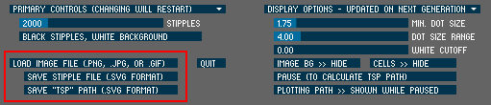

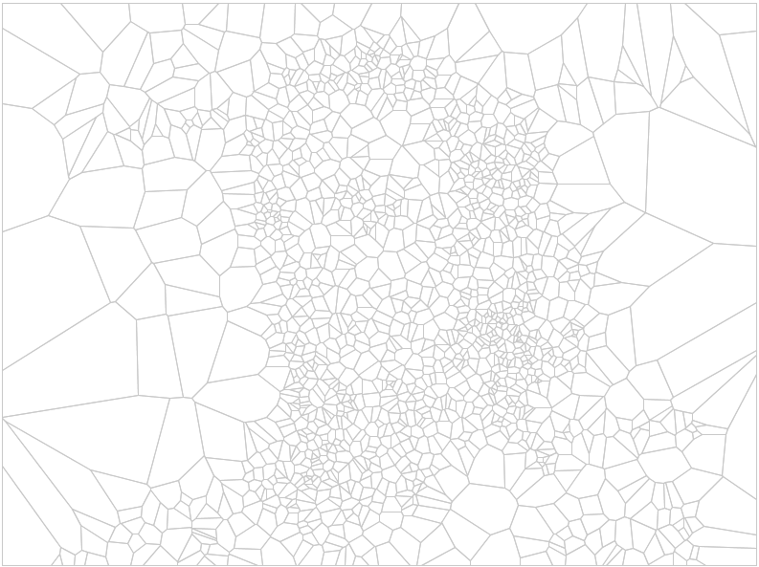To load a new image file, click the "Load Image File" button that is located above the "save" buttons. You can open any image file in .png, .jpg, .tga, or (non-animated) .gif formats. The file name must end in one of the following: .png, .jpg, .tga, .gif, .PNG, .JPG, .TGA, or .GIF.

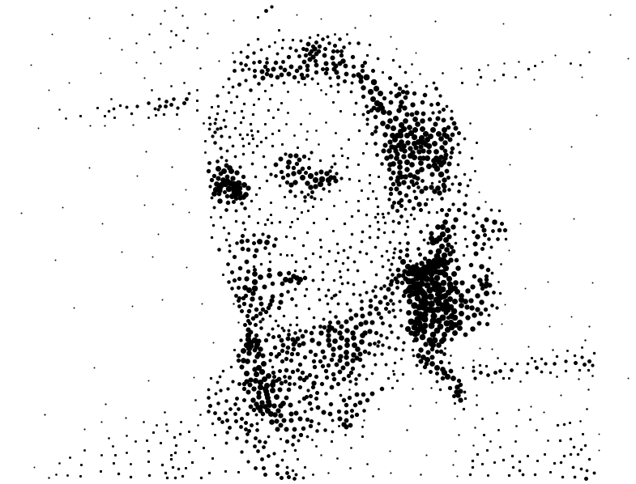

As soon as a new image is loaded, StippleGen will "sprinkle" an initial weighted distribution of points over the image and then begin to calculate an initial Voronoi diagram from those points. During this process, you will see something like the image shown above, which is the set of Voronoi cells for the initial point distribution. Depending on the number of stipples being calculated, this may be a matter of moments or minutes.

After the initial Voronoi diagram is calculated, StippleGen will display the stipple locations that it has calculated. This "first guess" is usually quite crude— as you can see above — and will improve dramatically as you allow StippleGen to run for a while.

*Aside:* The calculation of the stipple point locations through Secord's algorithm is an *iterative* process. For any given "generation," the process begins with an initial set of points— whether that's the initial set of "sprinkled' points, or the output from the previous generation. The Voronoi diagram of those points is then calculated, and each point is moved to the weighted centroid of its Voronoi cell. That distribution of points then serves as the starting point for the subsequent generation.

**Primary Controls**

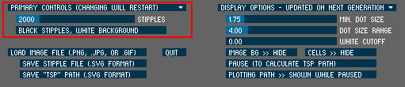

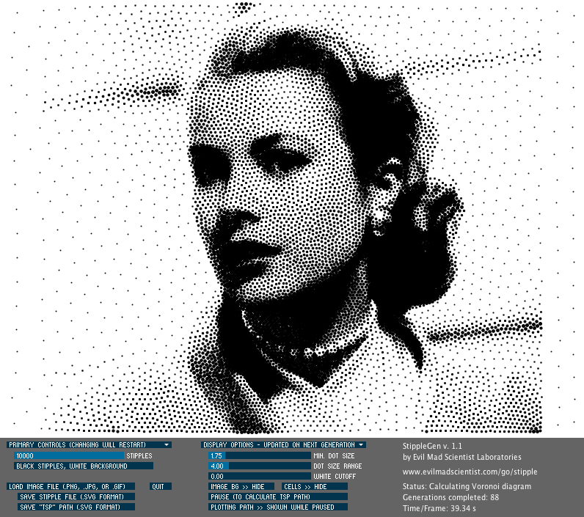

The two primary controls— which control the number and color of the stipples —are located in the upper-left portion of StippleGen's interface. Changing either setting will restart the calculation from the beginning, as though you had just loaded a new file.

You can adjust the number of stipples used in the calculation by dragging the position of the stipple count slider, labeled "STIPPLES." The default stipple count is 2,000, and it can be adjusted as high as 10,000. When you adjust the stipple count, you may wish to also wish to [adjust your display options](https://wiki.evilmadscientist.com/Stipplegen#Display_Options) to make the resulting image more clear.

Two important notes about changing the number of stipples: Using larger numbers of stipples will increase the time required per generation. And, again, please note that changing the number of stipples will restart the calculation from the beginning, as though you had just loaded a new file.

*Super-Secret Bonus Trick:* Press the 'x' key on your keyboard while StippleGen is running to increase the high end of the stipple count slider all the way up to 50,000. (We make no guarantee of how well StippleGen actually runs with more than 10k stipples. Our best guess: it takes its sweet time.)

**Stipple Color:**

StippleGen can create stipple drawings either with black dots on a white background or white dots on a black background. By default, StippleGen will begin drawing with black stipples on a white background. This is usually the best choice for working with images that are predominantly light in color.

To toggle between the two color schemes, press the wide button underneath the stipple-count slider, labeled with the current color scheme (typically "BLACK STIPPLES, WHITE BACKGROUND"). Pressing this button will switch the color scheme and restart the calculation from the beginning, as though you had just loaded a new file. Also, if you wish to restart the calculation for any reason, pressing this button twice is a good way to do that.

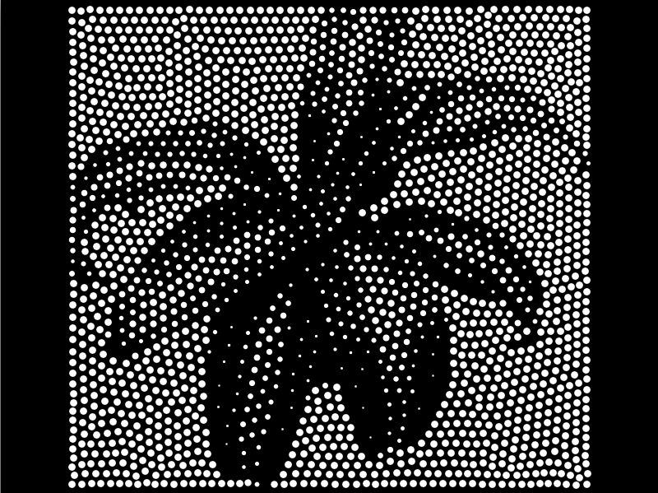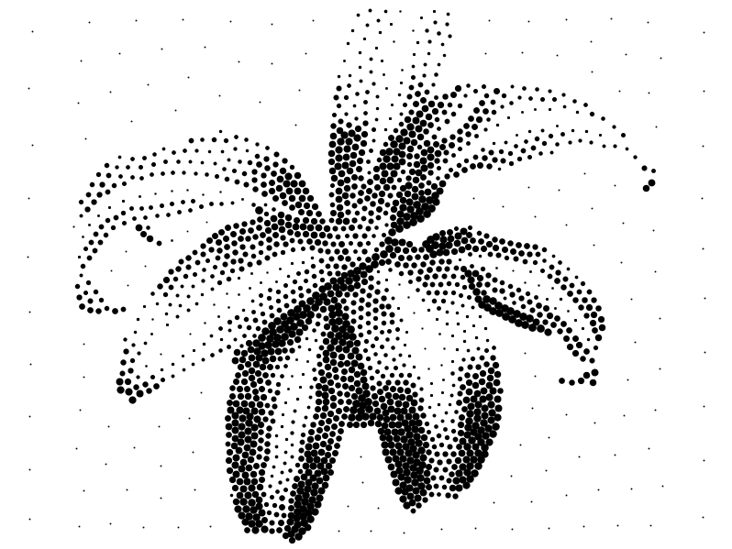

**Display Options**

The display options change how (and even, whether) the stipples are displayed, but do not actually affect their positions. These can be changed at any time without harming the stipple calculation, however, the results may not be visible (or fully applied) until the next generation is displayed.

Let's begin with a nicely optimized corn plant stipple drawing, with 10,000 stipple points. (At this stage we do not have any white cutoff.)

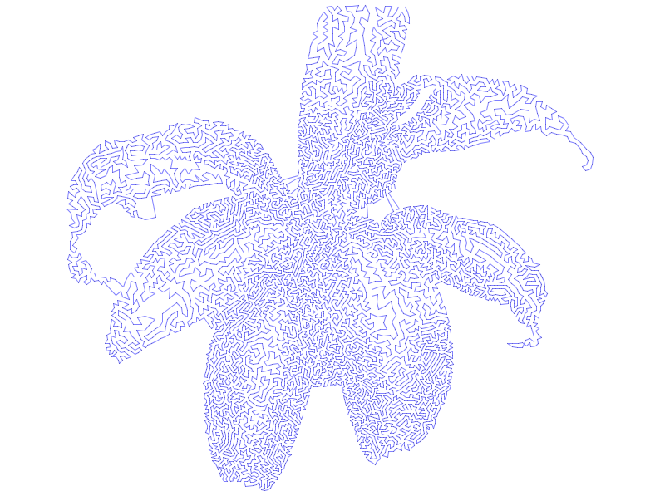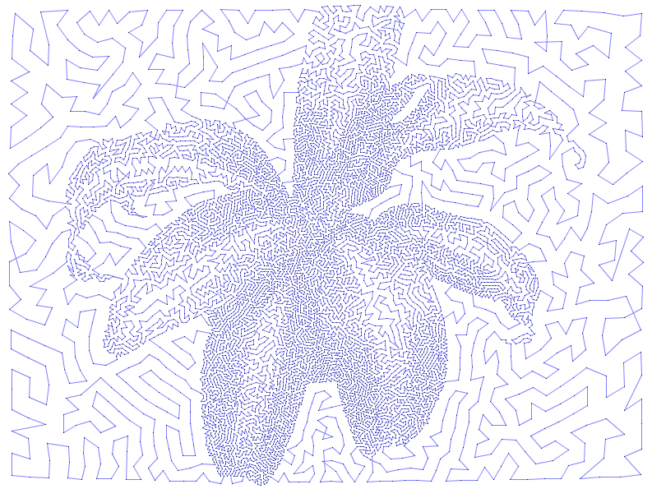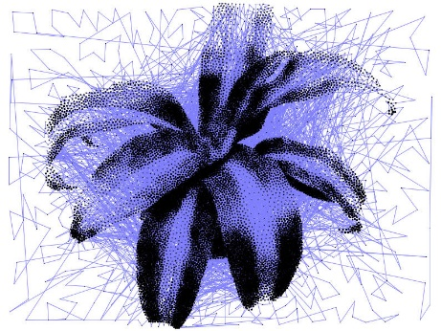

For this path, we've used the white cutoff to hide the background and allowed it to run for a few more minutes. This path probably won't get much better, so it's a good time to save the TSP path file. There are some little defects, but we're probably better off opening up the file in Inkscape at this point to edit away the bad path segments by hand.



#### File Format

The file is saved as an Inkscape SVG file that can be he superb (and free) vector graphics editor, or other applications that can open and edit Inkscape SVG files.

While the SVG file can be modified to your heart's content and subsequently saved in a wide variety of formats, the SVG file is initially formatted the drawing is centered in a document that is 3200 × 800 pixels, so that it can be used (without modification) as input for an